**Ahsanullah University of Science and Technology**



Department of Computer Science and Engineering

Program: Bachelor of Science in Computer Science and Engineering

Course No: CSE 4108

Course Title: Artificial Intelligence Lab

Project Report On: **Laptop Price Prediction**

Date of Submission: September 04, 2022

Submitted to:

Mr. Md. Siam Ansary

Lecturer, Department of CSE, AUST.

Ms. Tamanna Tabassum

Lecturer, Department of CSE, AUST.

Submitted by,

Name: Mustavi Ibne Masum Name: Arman Sakif Chowdhury

Student ID: 180204040 Student ID: 180204054

**Introduction:**

We will predict laptop price based on different useful features of a laptop of various brands. It will help the customers to decide about which laptop they want to buy and what laptop configuration they can get with their budget in mind. We created our own dataset and split it into 75/25 train-test and then calculated accuracy of our results from running different machine learning models. Lastly we took user input of the features which can predict price from the given feature.

**Dataset:**

We have constructed a working dataset of 242 laptops which we collected from [ryanscomputers](https://www.ryanscomputers.com/). We also created another dataset of 323 laptops from [startech](https://www.startech.com.bd/) but because it lacks cleaning and a lot of the data conflicts with ryans we didn’t use it.

Firstly we used beautifulsoup4 library of python to scrape raw data from websites and then we used python pandas to clean the data and create csv files.

Our working DS contains following attributes:

* Brand
* Processor
* Processor Generation
* RAM (in gigabytes)
* Storage (in gigabytes)
* Storage type
* Graphics
* Display size
* Display type
* Warranty
* Price

Following is a snapshot of our dataset: 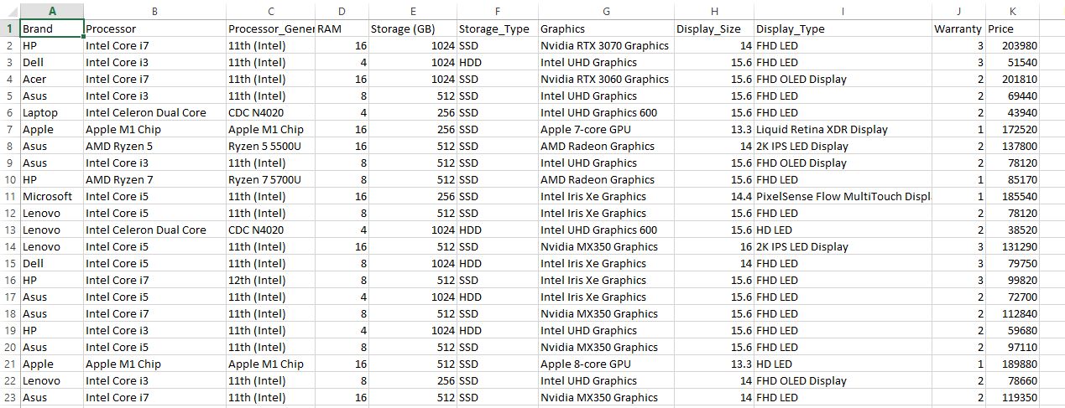

Number of rows: 241  
Number of attributes: 11

**ML Model**

1. **Multiple Linear Regression**

Multiple linear regression, also known as multiple regression, is a statistical technique that uses several explanatory variables to predict the outcome of a response variable. The goal of multiple linear regression is to model the linear relationship between the explanatory variables and response variables.

1. **Decision Tree Regression**  
   Decision tree builds regression or classification models in the form of a tree structure. It breaks down a dataset into smaller and smaller subsets while at the same time an associated decision tree is incrementally developed. The final result is a tree with decision nodes and leaf nodes. A decision node has two or more branches, each representing values for the attribute tested. Leaf node represents a decision on the numerical target. The topmost decision node in a tree which corresponds to the best predictor called root node. Decision trees can handle both categorical and numerical data
2. **K Nearest Neighbor(KNN)**

KNN regression is a non-parametric method that, in an intuitive manner, approximates the association between independent variables and the continuous outcome by averaging the observations in the same neighborhood. The size of the neighborhood needs to be set by the analyst or can be chosen using cross-validation to select the size that minimizes the mean-squared error.

1. **Gaussian Naïve Bayes**

Naive Bayes is a generative model. (Gaussian) Naive Bayes assumes that each class follows a Gaussian distribution. The difference between QDA (Qualitative Data Analysis) and (Gaussian) Naive Bayes is that Naive Bayes assumes independence of the features, which means the covariance matrices are diagonal matrices. Naive Bayes has class-specific covariance matrices.

1. **Random Forest Regression**

Random Forest Regression is a supervised learning algorithm that uses ensemble learning method for regression. Ensemble learning method is a technique that combines predictions from multiple machine learning algorithms to make a more accurate prediction than a single model. A Random Forest operates by constructing several decision trees during training time and outputting the mean of the classes as the prediction of all the trees.

**Comparison of Performance Scores**

|  |  |  |  |  |  |
| --- | --- | --- | --- | --- | --- |
| **Name of**  **Algorithm** | **Mean Absolute Percentage Error (%)** | **Mean Absolute Error** | **Mean Squared Error** | **Root Mean Squared Error** | **R2 Score** |
| Multiple Linear Regression | 15.46 | 18370.01 | 1211011714.60 | 34799.59 | 0.79 |
| Decision Tree Regression | 10.21 | 14998.45 | 1048202432.79 | 32375.95 | 0.82 |
| K Nearest Neighbor  (KNN) | 19.75 | 27568.20 | 2148541908.20 | 46352.37 | 0.63 |
| Gaussian Naïve Bayes | 12.88 | 22209.02 | 3284323185.25 | 57309.01 | 0.44 |
| Random Forest Regression | 9.01 | 13119.67 | 970795026.23 | 31157.58 | 0.83 |

**Discussion**As we can see, the error rates are relatively low and r2 score is quite well in some cases. This indicates that the model we have trained using the dataset have been well fitted. The least error and highest r2 score is seen in Random Forest Regression model. We can get even better result if we train our model using a larger dataset.